An Operating System provides services to both the users and to the programs.

* It provides programs, an environment to execute.
* It provides users, services to execute the programs in a convenient manner.

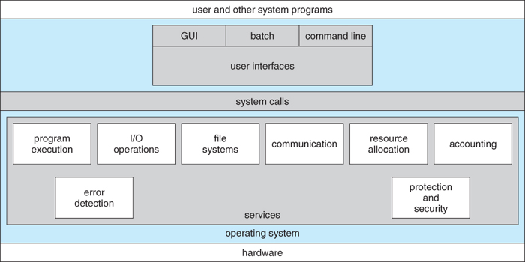

Following are few common services provided by operating systems.

* Program execution
* I/O operations
* File System manipulation
* Communication
* Error Detection
* Resource Allocation
* Protection

Program execution

Operating system handles many kinds of activities from user programs to system programs like printer spooler, name servers, file server etc. Each of these activities is encapsulated as a process.

A process includes the complete execution context (code to execute, data to manipulate, registers, OS resources in use). Following are the major activities of an operating system with respect to program management.

* Loads a program into memory.
* Executes the program.
* Handles program's execution.
* Provides a mechanism for process synchronization.
* Provides a mechanism for process communication.
* Provides a mechanism for deadlock handling.

I/O Operation

I/O subsystem comprised of I/O devices and their corresponding driver software. Drivers hides the peculiarities of specific hardware devices from the user as the device driver knows the peculiarities of the specific device.

Operating System manages the communication between user and device drivers. Following are the major activities of an operating system with respect to I/O Operation.

* I/O operation means read or write operation with any file or any specific I/O device.
* Program may require any I/O device while running.
* Operating system provides the access to the required I/O device when required.

File system manipulation

A file represents a collection of related information. Computer can store files on the disk (secondary storage), for long term storage purpose. Few examples of storage media are magnetic tape, magnetic disk and optical disk drives like CD, DVD. Each of these media has its own properties like speed, capacity, data transfer rate and data access methods.

A file system is normally organized into directories for easy navigation and usage. These directories may contain files and other directions. Following are the major activities of an operating system with respect to file management.

* Program needs to read a file or write a file.
* The operating system gives the permission to the program for operation on file.
* Permission varies from read-only, read-write, denied and so on.
* Operating System provides an interface to the user to create/delete files.
* Operating System provides an interface to the user to create/delete directories.
* Operating System provides an interface to create the backup of file system.

Communication

In case of distributed systems which are a collection of processors that do not share memory, peripheral devices, or a clock, operating system manages communications between processes. Multiple processes with one another through communication lines in the network.

OS handles routing and connection strategies, and the problems of contention and security. Following are the major activities of an operating system with respect to communication.

* Two processes often require data to be transferred between them.
* The both processes can be on the one computer or on different computer but are connected through computer network.
* Communication may be implemented by two methods either by Shared Memory or by Message Passing.

Error handling

Error can occur anytime and anywhere. Error may occur in CPU, in I/O devices or in the memory hardware. Following are the major activities of an operating system with respect to error handling.

* OS constantly remains aware of possible errors.
* OS takes the appropriate action to ensure correct and consistent computing.

Resource Management

In case of multi-user or multi-tasking environment, resources such as main memory, CPU cycles and files storage are to be allocated to each user or job. Following are the major activities of an operating system with respect to resource management.

* OS manages all kind of resources using schedulers.
* CPU scheduling algorithms are used for better utilization of CPU.

Protection

Considering a computer systems having multiple users the concurrent execution of multiple processes, then the various processes must be protected from each another's activities.

Protection refers to mechanism or a way to control the access of programs, processes, or users to the resources defined by a computer systems. Following are the major activities of an operating system with respect to protection.

* OS ensures that all access to system resources is controlled.
* OS ensures that external I/O devices are protected from invalid access attempts.
* OS provides authentication feature for each user by means of a password.